TITLE OF THE PRODUCT – EDEN FIST

TEAM DESCRIPTION - 1. VAISHNAVI SHUKLA 21MIS1100

2. RAJ KOYANI 21MIS1017

3. ADWAITA JHA 21MIS1186

\* PRINCIPAL CLAIMS :-

* It is affordable as the components required are very few and is user-friendly.
* This reduces the communication gap faced by the disabled.
* It also provides communication between the dumb and coma recovered.
* It is also useful for speech-impaired and Paralyzed patients.
* It's lightweight and flexible for users.
* Easy to operate and real-time usage dependent.
* High buzzer sound.

\*DEPENDENT CLAIMS:-

* Accurate oxygen rate reading.
* Easy/comfortable to wear.
* Fits accurately on patient’s finger.
* Light weight.

\*FLOWCHART DIAGRAM

SMART GLOVE + OXIMETER

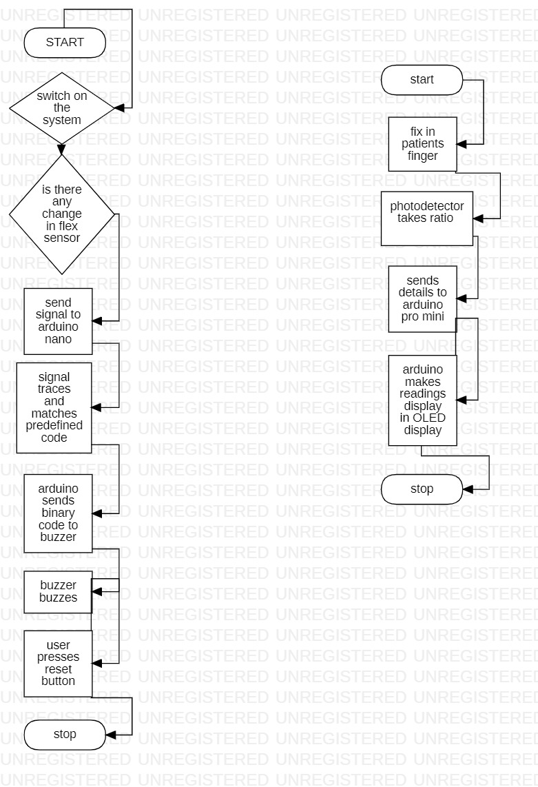

\*ARCHITECTURAL DIAGRAM :-

